City of Garland
ArcGIS Class Extension
Administrators Guide

Introduction
The City of Garland street project includes four class extensions that perform custom functionality in the ESRI geodatabase. Because these class extensions hook directly into the geodatabase rather than the user interface of a particular program, this custom functionality is available to any program that uses the geodatabase – such as ArcCatalog or ArcMap. The advantage of this approach is that the custom functionality cannot be bypassed (unless changes are made outside the geodatabase in the underlying database). The disadvantage is that the class extensions must be present for any client to view the classes created with these extensions – even if the client is only going to view the data and not edit it. These class extensions will work for any variety of geodatabase such as a personal geodatabase or SDE enterprise geodatabase.

NOTE: The class extensions must be installed for any PC used to view the classes created with these extensions

The following four class extensions are included in this project: base feature class, street master table, street feature class and street alias table.

Base Feature Class
Similar to the ArcGIS objectID column, the base feature class provides a user-defined auto-incrementing ID column. Once assigned, this ID cannot be changed and the ID remains unique across all versions in the geodatabase. Several methods are available for storing the ID allowing the administrator to select the best method for their geodatabase configuration.

The base feature class can also track who made edits to the feature and when the edits were made using user-defined fields in the feature.

The base feature class functionality is used in all other custom feature classes.

Master Street Table
A master street table stores a list of street names to be used by other features. Related street features may only select street names that exist in its master street table. As changes are made to the master street table, they are also applied to related street features. Changes may also optionally be recorded in a street alias table.

When a street name in the master street table is updated, all records in related street features are updated to display this new street name. The old name is then recorded in the street alias table. When a street name in the master street table is deleted, the user is prompted to select a replacement street. Any records in related street features using the old street name are updated with the replacement street name. The deleted street name is placed in the alias table as an alternate name for the replacement street.

Street Feature Class
A street feature class is restricted to selecting a street from its master street table. When a street is selected from the street list domain, all the fields of street name components – prefix, name, street type and suffix - are updated to reflect the new entry. The individual street name components may not be edited on a street feature. Changes to a street name should be made to the master street table and then they will be automatically reproduced in the street feature classes.

Street Alias Table
A street alias table records changes to street name made in the master street table. This table is useful for tracking alternate names for in geocoding addresses.

Setting Properties
Each class extension has its own set of properties used to configure how it behaves. To configure these properties, display the feature class property dialog by right-clicking on the feature in ArcCatalog. Use the Garland tab on the properties dialog to display the options for each class extension.
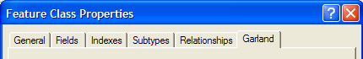
Figure 1-1: The Garland tab displays the custom settings

Base Feature Class

TimeStamp Fields
Three fields are available for tracking who and when edits were made to features.

Field | Description
Date Created Field | A timestamp when the feature was created
Last Modified Field | A timestamp when the feature was modified
User Name Field | The Windows login of the user who created or modified the feature

If you don’t want to use all the fields, you may set them to “NOT IN USE”.

NOTE: If you rename the fields, make sure to assign them in the properties dialog box.

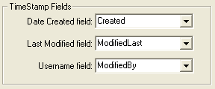
Figure 2-2: Base Feature Timestamp Fields

Auto-incrementing ID column
Similar to the ObjectID column that ESRI provides to internally identify a feature, this function provides an incremental id for the user to uniquely identify the feature. This user id column will automatically populate and can not be altered once set. This id will not be re-used and is unique across all version of a single feature class.

Three different mechanisms are available to calculate the next user id:
- The “Max ID” method which calculates the id internally
- The “User ID Table” method which stores the next id for a feature in a table
- The “Oracle Sequence” method which uses an Oracle specific mechanism to provide the next number in a sequence.

MaxID Method
This method is the default for personal geodatabases and works only when there is a single user editing at a time. When a new feature is created in the base feature class, this method calculates the highest id and increments it by one. The next id for all subsequent features is maintained in memory.

Advantages | Disadvantages
- No external storage of ids is required  - Possible reuse of deleted ids, if they are at the end of the sequence. When the edit session is restarted, the max id is calculated from the highest existing feature. | - Requires a single editor at a time  - Initial calculation of maximum id number may be slow if the feature class has many features

To view the ID Field settings, right click on the feature in ArcCatalog and choose properties. On the Garland Tab, see the settings in the ID Field section.

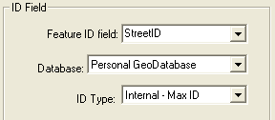
Figure 2-3: Base Feature properties for MaxID method

User ID Table Method
This method stores the next id for a particular feature in a table called UserIDs. While this table is stored in the geodatabase, it must be accessed outside of the geodatabase to guarantee that the IDs are unique across all versions within the geodatabase. To accomplish this, this method requires a Microsoft ActiveX Data Objects (ADO) connection directly to the underlying database supporting the geodatabase.

The ADO connection is used to
- Create the UserIDs table if it doesn’t exist
- Retrieve and set the next id

The database connection string is set when the feature class is first created using the same connection information used to connect to the geodatabase. The database connection string may set in the properties dialog.

NOTE: While the class extension reads most of the connection information from the geodatabase connection properties, it cannot read the password since it is encrypted by ArcCatalog when the connection is made. If using this method for an SDE geodatabase, you must manually set the password on the database string. Make sure the save password option is checked when creating the database connection string.

This method is the default for SDE geodatabases on SQL Server
Advantages | Disadvantages
- Supports multiple users making simultaneous edits  - No lag time for calculating the maximum id so good for large datasets  - The next id may be set in the database  - UserIDs table may be stored in separate database from geodatabase | - UserIDs table is available for editing  - Database connection string visible to user

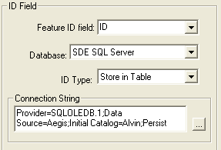
Figure 2-4: Base Feature properties for UserID
table method

Oracle Sequence
This method is only available for an SDE geodatabase stored in an Oracle database.

Your DBA must create the sequence in the Oracle database prior to creating the feature.

Advantages | Disadvantages
- Supports multiple users making simultaneous edits  - No lag time for calculating the maximum id so good for large datasets  - The next id may be set in the database | - Sequence must be created by a DBA  - Database connection string visible to user

NOTE click the button to load the list of Oracle sequences

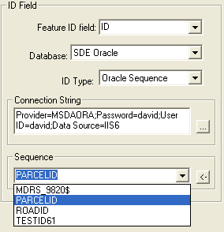
Figure 2-5: Base Feature properties for Oracle Sequence method

Creating a Base Feature Class
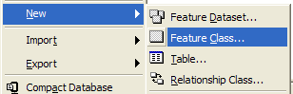
Figure 2-6: New > Feature Class

New Feature Class Dialog
- In ArcCatalog, Right click on the geodatabase and select New > Feature Class to display the New Feature Class dialog
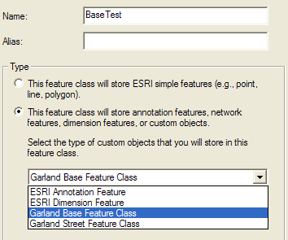
Figure 2-7: Create a Garland Base Feature Class

- Enter a Name for the Feature
- Select the “This table will store custom objects” radio button
- Select Garland Base Feature Class from the pick list as shown in Figure 2-7

- Click Next to the Specify Configuration Keyword. Enter the values as you would for any other class in the geodatabase
- Click Next to view the Field Definitions. You may add, remove or edit fields as necessary.
- Set the Field Properties for the Shape field
- Click the Finish Button

View the Properties
- Right click on the Base Feature Class and choose properties to display the Feature Class Properties dialog.
- Select the Garland Tab

Set the ID Field Settings
Figure 2-8: ID Field Settings for UserID table method
- If using SDE, you must set the connection string. To set the connection string, click the button to display the Data Link Properties dialog.
- Enter the database connection settings.
NOTE All users will use this connection string
- Click the Test Connection button to check your setting
- Make sure the Allow Saving Password check is selected

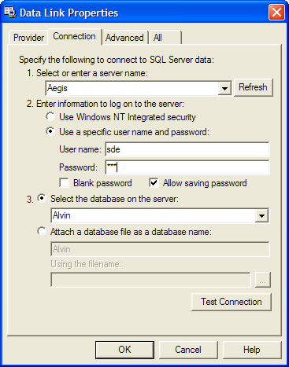
Figure 2-9: Data link properties dialog

Street Master Table
The Street Master table stores a list of street names that serves as the source of streets that may be assigned to related street features. Renamed streets are stored in a Street Alias table.

Creating a Street Master Table

New Table Dialog
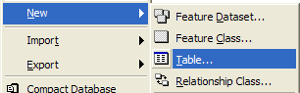
Figure 3-10: New > Table
- In ArcCatalog, Right click on the geodatabase and select New > Table to display the New Table dialog

- Enter a Name for the Table
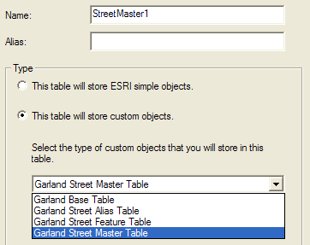
Figure 3-11: Create a New Street Master Table

- Select the “This table will store custom objects” radio button
- Select Garland Street Master Table from the pick list as shown in Figure 3-11

- Click Next to the Specify Configuration Keyword. Enter the values as you would for any other class in the geodatabase
- Click Next to view the Field Definitions as shown in Figure 3-12. Add field as necessary but do not change the street fields
NOTE: The StreetID, StreetPrefix, StreetName, StreetType, StreetSuffix and StreetLabel fields are required and the names should not be changed.
- Click the Finish Button

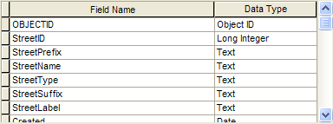
Figure 3-12: Fields include in street master table

View the Properties
- Right click on the Street Master table and choose properties to display the Table Properties dialog.
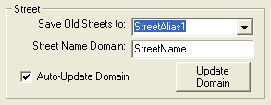
Figure 3-13: Street Master Table properties
- Select the Garland Tab

- The Street Alias picklist will display any alias tables in the geodatabase
- The street Name Domain text box is used to specify the name of the domain that will contain the street names in this master table
- Check the Auto-update domain checkbox to assure that the domain is maintained as entries are made in the street master table
- Click the Update Domain button at any time to refresh the domain with the entries in the street master table

Adding a Street Name

Individually in ArcEditor
To add a new street name, start an ArcEditor edit session and enter the following fields:

Field Name | Description | Example
StreetID | Unique ID for the street. Automatically created and may not be edited
StreetPrefix | Pre-directional | N
StreetName | Street name | Main
StreetType | Four character abbreviation for street type | St
StreetSuffix | Post directional | W
StreetLabel | Composite of street parts. Automatically created and may not be edited | N Main St W

When the name is entered, the following occurs
- Streetid is assigned
- StreetLabel is created
- If “Auto-update domain” is checked, the new street name is added in the domain associated with street master table

NOTE: Save your changes before assigning this new entry to a street feature in the same edit session.

Bulk Insert in ArcCatalog
The Load Data command in ArcCatalog may be used to insert multiple streets into the street master table. If “Auto-update domain” is checked, the domain is deleted and recreated with each new street. Because this process is repeated iteratively, it may slow down the import process. To avoid this situation, turn off the “Auto-update domain” option, import the data, then click the Update Domain button to recreate the domain after the import is complete.

Changing a Street Name
When a street name is updated, the following occurs:
- A new street label is created in the street master table
- The street information is updated in any street feature classes related to this street master table
- If “Auto-update domain” is checked, the domain is deleted and recreated with the updated street.
- If an alias table is assigned, the old name (before the edit) is stored in the alias table as an alias for the new (after the edit) street name

Deleting a Street Name
When a street name is deleted, the following occurs:
- You will be prompted to select a replacement street to assign to any segments that still have this street assigned.
  - If you select a replacement street, the street information is updated in any street feature classes related to this street master table
  - If you do not select a replacement street, the street information is updated to blanks in any street feature classes related to this street master table. The missing domain entry will appear as “<NULL>”
- If “Auto-update domain” is checked, the street is removed from the domain.
- If an alias table is assigned, the deleted name is stored in the alias table as an alias for the replacement street id

NOTE
- When changes are canceled in an edit session, changes to the street master table, alias table and related street features are undone. However, changes to the domain are not undone causing the domain to get out of synch with the street master table. To correct this, refresh the domain in properties dialog using the Update Domain button.
- When a master street table is edited, related street features are also updated. In ArcEditor, the screen may need to be refreshed for labels to reflect the attribute changes made to related street features.
- If a domain entry is deleted, but is still in use, the domain description is shown as null. Labels on the domain field will display the code value instead of the description.
- Make sure changes to save changes to the street master table, before assigning the new street to street features.

Street Feature Class

Create a New Street Feature Class
Figure 4-14: New > Feature Class

New Feature Class Dialog
- In ArcCatalog, Right click on the geodatabase and select New > Feature Class to display the New Feature Class dialog
- Enter a Name for the Table
- Select the “This table will store custom objects” radio button
- Select Garland Street Master Table from the pick list as shown in Figure 3-11
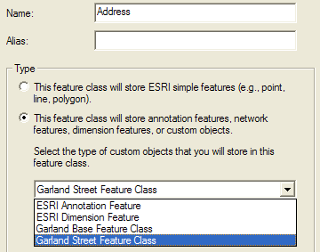
Figure 4-15: Create a Garland Street Feature Class

- Click Next to the Specify Configuration Keyword. Enter the values as you would for any other class in the geodatabase
- Click Next to view the Field Definitions
- Add field as necessary but do not change the street fields
- Set the geometry field settings for the Shape field

NOTE: The StreetID, StreetPrefix, StreetName, StreetType, StreetSuffix and StreetLabel fields are required and the names should not be changed.
- Click the Finish Button

View the Properties
- Right click on the Street Master table and choose properties to display the Table Properties dialog.
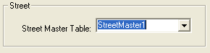
Figure 4-16: Street Feature Class properties
- Select the Garland Tab
- Select the associated Street Master table from the pick list

NOTE: When you select the street master table associated with the street feature class, the domain maintained by the street master table is assigned to the StreetID field of the street feature class.

Adding the Street Name
To assign a street name to a new feature, use the domain assigned to the StreetID field. You can not edit the individual street parts such as StreetPrefix, StreetName, StreetType, StreetSuffix and StreetLabel. These are automatically populated from the master street table when the street is selected from the domain.

Street Alias Table
This table is used to record alternate names created during street name maintenance on the street master table. Records in this table may be edited as necessary to remove or edit entries created by mistakes in street name entry.

Create a New Street Alias Table

New Table Dialog
Figure 5-17: New > Table
- In ArcCatalog, Right click on the geodatabase and select New > Table to display the New Table dialog

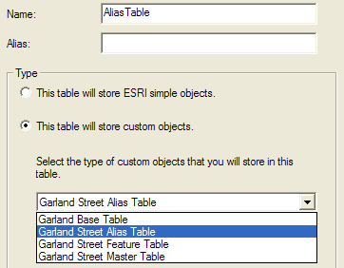
Figure 5-18: Create a Garland Street Alias Table
- Enter a Name for the Table
- Select the “This table will store custom objects” radio button
- Select Garland Street Alias Table from the pick list as shown in Figure 5-18

- Click Next to the Specify Configuration Keyword. Enter the values as you would for any other class in the geodatabase
- Click Next to view the Field Definitions
- Add field as necessary but do not change the street fields
- Set the geometry field settings for the Shape field

NOTE: The StreetID, StreetPrefix, StreetName, StreetType, StreetSuffix and StreetLabel fields are required and the names should not be changed.
- Click the Finish Button

Class Extension Administration

Installing the extensions
The class extensions are installed using the delivered setup.msi file which will create an entry titled Garland ArcGIS Extensions in the Add Remove/Programs control panel. The extensions may be installed or removed the same as any other Windows application.

To install the Garland class extensions, double-click the delivered setup.exe file and follow the prompts.

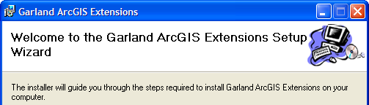
Figure 6-19 : The Garland class extension installer

Manually removing the extension
The class extensions must be installed on any PC in order to view any features created with these extensions. If the extensions are not available, the user will not be able to view the data unless the extensions are manually removed from the feature.

NOTE ESRI does not recommend making changes directly in the geodatabase settings tables.

To remove the extension from the class:
- Open the GDB_ObjectClasses table in the geodatabase
- Locate the record for the feature class using the value in the Name column
- Delete the value from the EXTCLSID
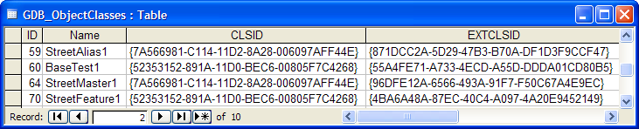
Figure 6-20: Delete the EXTCLSID for the feature class in the GDB_ObjectClasses table

Apply an extension to an existing feature
ArcCatalog may be used to create new feature classes and tables using the class extensions. However, they can also be applied to existing features in the geodatabase by manually associating the extension with the feature class.

NOTE You must make sure the requirements for the class extension are met by the existing feature class such as having the appropriate columns of the correct type. The class extensions must be installed before manually adding the extension to a feature.

NOTE ESRI does not recommend making changes directly in the geodatabase settings tables.

To add the extension to a class:
- Open the GDB_ObjectClasses table in the geodatabase
- Locate the record for the feature class using the value in the Name column
- Add the value from the EXTCLSID as shown in Figure 6-20

Class Name | EXTCLSID
Base Feature | {55A4FE71-A733-4ECD-A55D-DDDA01CD80B5}
Street Master Table | {96DFE12A-6566-493A-91F7-F50C67A4E9EC}
Street Feature | {4BA6A48A-87EC-40C4-A097-4A20E9452149}
Street Alias Table | {871DCC2A-5D29-47B3-B70A-DF1D3F9CCF47}
Figure 6-21: The Class IDs of the class extensions

